

Project Name: RENT-IT

Branch PG-DAC Sept- 2021.

Documentation On

**“RENT-IT”**

PG-DAC SEPT 2021

**Guided By: Snehal Somwanshi**

Submitted By :

**Group No: 20**

* **Aarati Kolhe 210943020038**
* **Nachiket Gawali 210943020054**
* **Rahul Yalgude 210943020070**
* **Ritesh Sarade 210943020071**

**Table of Contents**

**1. Introduction 4**

1.1 Document Purpose 4

1.2 Project Background 4

1.3 Aim & Objectives 4

**2. Business Requirements Overview**…………………………………………………………**5**

**3.Functional Requirements** **5**

3.1 Customer Module 5

3.2 Admin Module 6

**4.** **Non-Functional Requirement……………………………………………………………….6**

**5. Use Case Diagram 7**

5.1 Customer 7

5.2 Admin 8

**6. Database Design……………………………………………………………………………9**

1 Logins……………………………………………………………………………………...9

2 Customers ………………………………………………………………………………….9

3 Admin………….…………………….…………………………………………………….9

4 Category…………………………………………………………………………………...9

5 Product…………………………………………………………………………………….10

6 Oder Items…………………………………………………………………………………10

7. Order Details………………..…………………………………………………………….10

8. Delivery Executive………………………………………………… ……………………10

**7. E-R Diagram………………………………………………………………………………………...11**

**8. Snapshots…………………………………………………………………………………...12**

**9. Conclusion…………………………………………………………………………………..16**

**List of Figures**

**Use Case Diagrams 7**

Fig 1 Customer 7

Fig 2 Admin 8

Fig 3 Branch Manager 9

Fig 4 Delivery Executive 10

Fig 5 ER-Diagram…………………………………………… ……………………………15

1. **Introduction:**
   1. **Document Purpose:**

This document explains the system requirements and scope for developing Rent-It System.

Rent-It System could divide into the four main parts: Admin Part, Customer Part, Message Acknowledgement Part and Payment Gateway.

## Project Background:

. Now-a-days many youth frequently need to shift their location for their job or any other reason. At such time they need lots of home appliances for regular use. So buying the new appliances for limited time use is not possible. So renting appliances is good option for such people.

Generally people visit nearest market for renting the products. But finding the affordable shop in new unknown location becomes difficult. Every shop tries to cuts his commission out of that. There is no way for people to know about the deal and the exact amount of rent to be paid. There is no transparency and trust as well. No facility is present for the peoples to know the product rates at different markets where they can buy it on rent.

## Aim & Objectives:

* The main objective of this project is building a website which will help mainly targeting the young population who has mobile nature of jobs for renting the home appliances or other necessary things.
* Rent-It will be an online portal where users can search for home appliances which can be rented at reasonable amount.
* User can register and search for the required Appliance from the available inventory options.
* If the user is interested in renting the product, he can then proceed with the rental formalities. Rental will include a deposit amount which will be refunded to the customer on returning.
* Streamline the Online rental home appliances.

1. **Business Requirements Overview:**
2. Rent-It is the public web application.

1. Rent-It will be opened to the India, but in the phase 1, the main target is in the Maharashtra.

1. Customer can search for the rental appliances on the website.

1. Rent-It provides the functions which connect the restaurant vendors and the customer efficiently.
2. Rent-It System could be maintained by Administrator.

# 

# Functional Requirements Overview:

Rent-It System consists of two modules described as below.

1. Customer Module
2. Admin Module

**3.1 Customer Module**

* + - * End Users will be able to view available home appliances, furniture and Electronics for renting online using their laptops and computer machines.
      * End Users will be able to select home appliances from the category and find information such as name of product, renting price and desired quantity.
      * End Users will be able to manage their order in personalized manner, he/ she can add or remove items from cart.
* Only Registered customers will be allowed to place an order for items added into their respective Cart.
* Registered Customer can cancel placed order.
* Registered Customer can view Orders History using portal.
* Registered Customer is allowed to change his personal details such as personal Address and Delivery Address.

**3.2 ADMIN MODULE:**

* + - * Login.
      * Add, Update, Delete product for rent
* View order log of all customer
* View payment log for all customer
* Report Generation

1. **Non-Functional Requirement:**

* The website should use professional design, look and feel and color scheme.
* Users will have no limitations for accessing the application through Internet. The portal being an internet application, it is difficult specify exact number of visitor or users. Hence we will target the system to support between 5 and 10 million users on launch of phase 1.
* Being a public website, the site must follow general usability guidelines for menus, navigation, colors, links and other actions provided on the screens.
* The system should be designed in such a manner that user will be able to complete tasks in minimum number of steps.

## Use-Case Diagram

## 5.1 Customer:

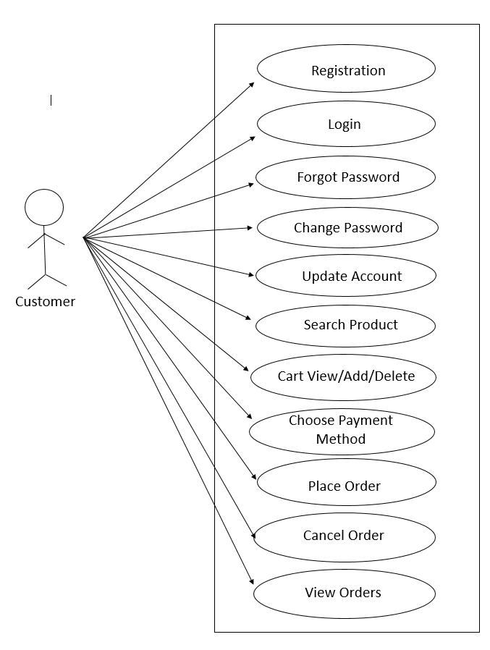

Fig. Use-Case Diagram for Customer

**5.2 Admin:**

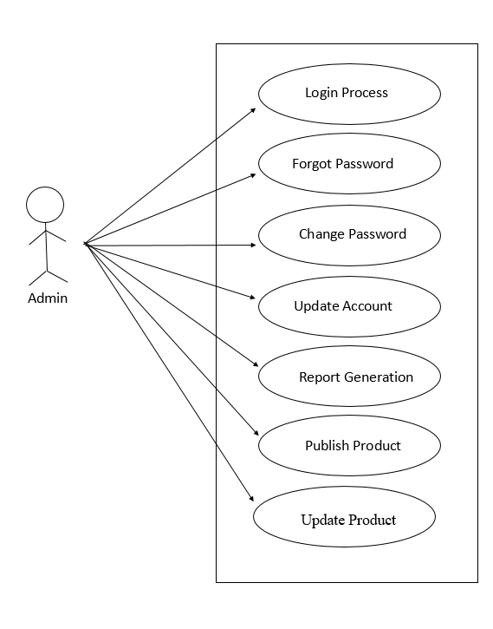

Fig. Use-Case Diagram for Admin

**Database Design:**

**1.logins:**

|  |  |
| --- | --- |
| **Default** | **Description** |
| Null | Login ID |
| Null | User Name |
| Null | Password |
| Null | Role |

**2.customers:**

|  |  |  |  |  |  |
| --- | --- | --- | --- | --- | --- |
| **Customer** | | | | | |
| **Field** | **Type** | **Null** | **Key** | **Default** | **Description** |
| c_id | int | No | pk | Null | Customer ID |
| c_fname | varchar | No |  | Null | Customer Name |
| c_lname | varchar | No |  | Null | Customer Last Name |
| aadhar_no | int | No |  | Null | Customer Aadhar Number |
| c_email | varchar | No |  | Null | Customer Email ID |
| c_contact | int | No |  | Null | Customer Contact Number |
| c_area | varchar | No |  | Null | Customer Area |
| c_pincode | varchar | No |  | Null | Customer Pincode |
| c_city | varchar | No |  | Null | Customer City Name |
| login_id | varchar | No | fk | Null | Customer Login ID |

**3.admin:**

|  |  |  |  |  |  |
| --- | --- | --- | --- | --- | --- |
| **Admin** | | | | | |
| **Field** | **Type** | **Null** | **Key** | **Default** | **Description** |
| a_id | Int | No | pk | Null | Admin ID |
| fname | varchar | No |  | Null | First name |
| lname | varchar | No |  | Null | Last name |
| email | varchar | No |  | Null | Email ID |
| contact | varchar | No |  | Null | Contact no |
| login_id | Int | No | fk | Null | Login ID |

**4.category:**

|  |  |  |  |  |  |
| --- | --- | --- | --- | --- | --- |
| **Category** | | | | | |
| **Field** | **Type** | **Null** | **Key** | **Default** | **Description** |
| cat_id | Int | No | pk | Null | Category ID |
| cat_name | varchar | No |  | Null | Category Name |

**5.Product**

|  |  |  |  |  |  |
| --- | --- | --- | --- | --- | --- |
| **Product** | | | | | |
| **Field** | **Type** | **Null** | **Key** | **Default** | **Description** |
| p_id | int | No | pk | Null | Product ID |
| p_name | varchar | No |  | Null | Product Name |
| p_description | varchar | No |  | Null | Product Description |
| p_rentprice | int | No |  | Null | Product Rent Price |
| p_deposit | int | No |  | Null | Product Deposit amount |
| image | varchar | No |  | Null | Images of Product |
| cat_id | int | No | fk | Null | Category ID |

**6.Order Item**

|  |  |  |  |  |  |
| --- | --- | --- | --- | --- | --- |
| **Order Item** | | | | | |
| **Field** | **Type** | **Null** | **Key** | **Default** | **Description** |
| item_id | int | No | pk | Null | Item ID |
| item_cost | int | No |  | Null | Item Cost |
| rent_date | int | No |  | Null | Item Rent Date |
| return_date | int | No |  | Null | Item Return Date |
| p_id | int | No | fk | Null | Product ID |
| order_id | int | No | fk | Null | Order ID |

**7. orders details**

|  |  |  |  |  |  |
| --- | --- | --- | --- | --- | --- |
| **Order details** | | | | | |
| **Field** | **Type** | **Null** | **Key** | **Default** | **Description** |
| order_id | int | No | pk | Null | Order ID |
| order_price | int | No |  | Null | Order Price |
| rent_date | int | No |  | Null | Order Rent Date |
| status | varchar | No |  | Null | Status of Order |
| c_id | int | No | fk | Null | Customer ID |
| d_id | int | No | fk | Null | Delivery Executive ID |

**8. delivery Executive**

|  |  |  |  |  |  |
| --- | --- | --- | --- | --- | --- |
| **Delivery Executive** | | | | | |
| **Field** | **Type** | **Null** | **Key** | **Default** | **Description** |
| d_id | int | No | pk | Null | Delivery Executive ID |
| d_fname | int | No |  | Null | Delivery Executive First Name |
| d_lname | int | No |  | Null | Delivery Executive Last Name |
| d_email | varchar | No |  | Null | Delivery Executive Email ID |
| d_contact | int | No |  | Null | Delivery Executive Contact Number |
| d_servicepincode | int | No |  | Null | Delivery Executive Pincode |
| login_id | int | No | fk | Null | Delivery Executive Login ID |

## 7. ER-Diagram:

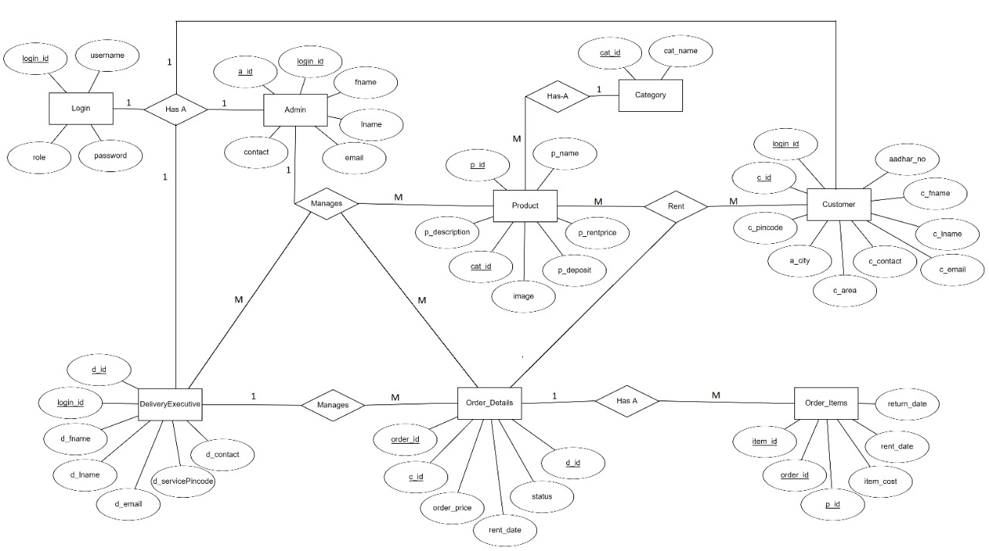

**E-R diagram shows database of Rent-It**

**8. Snapshots:**

**8.1 Home Page:**

Following snapshot shows the home page for Rent-It.

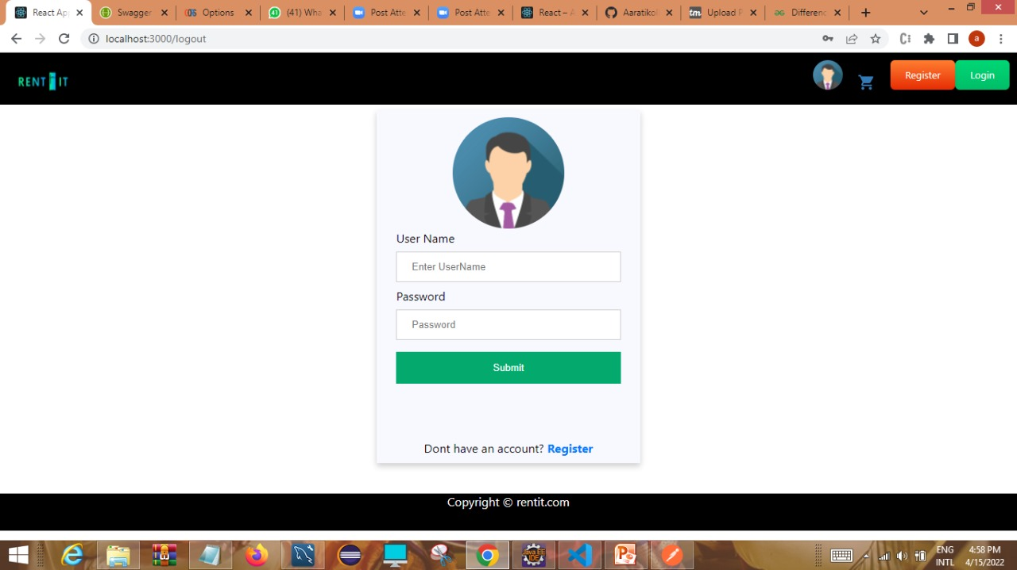

This page contains following controls

* Home
* Login
* Register

**8.2 Registration Page**

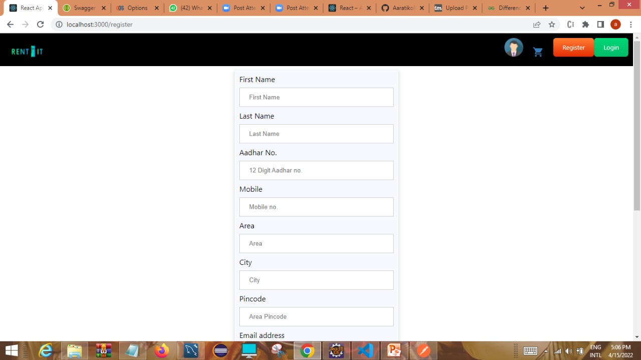

**8.3 Login Page**

Following snapshot shows the Login page for Rent-It.



**8.4 Admin’s Additional Functionality**

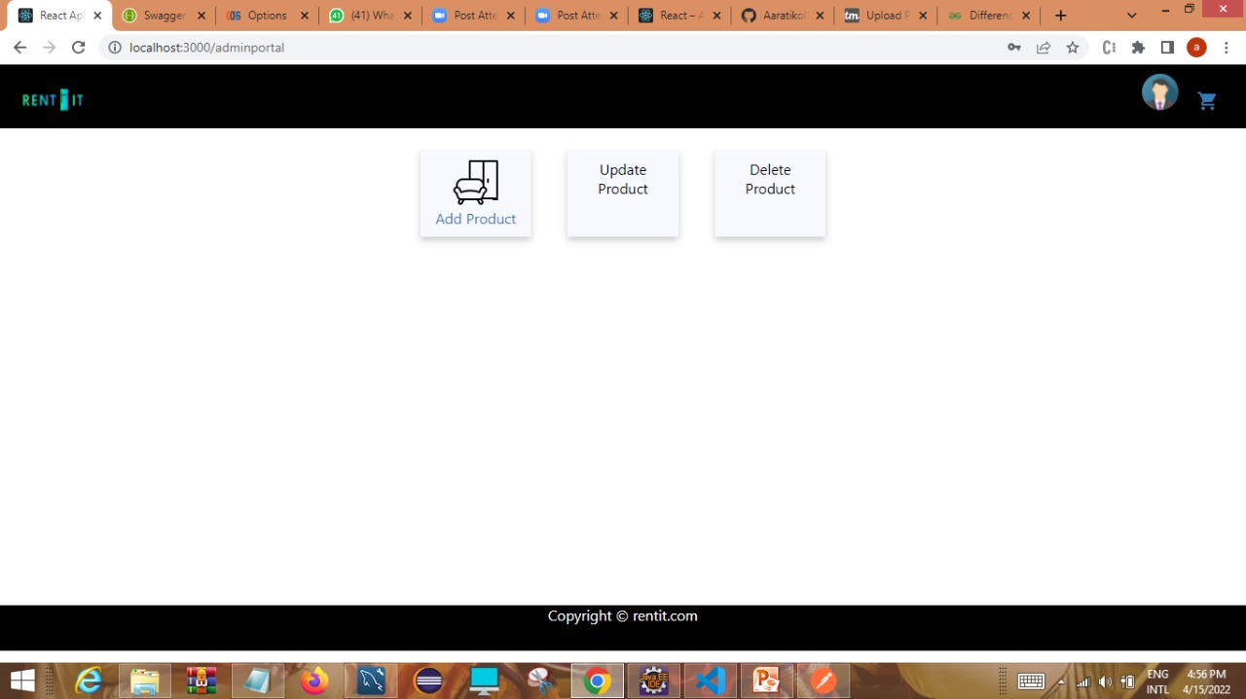

**8.5 Category for rental products**

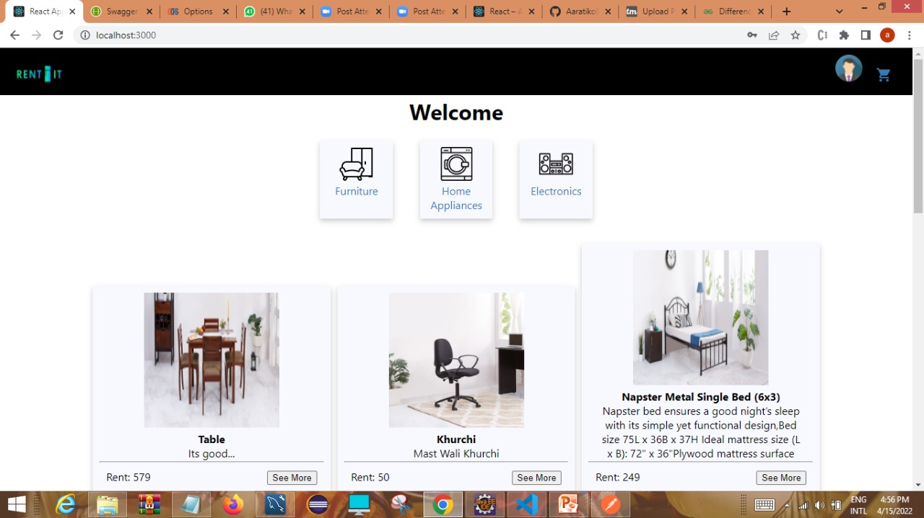

**8.6 View Cart Page**

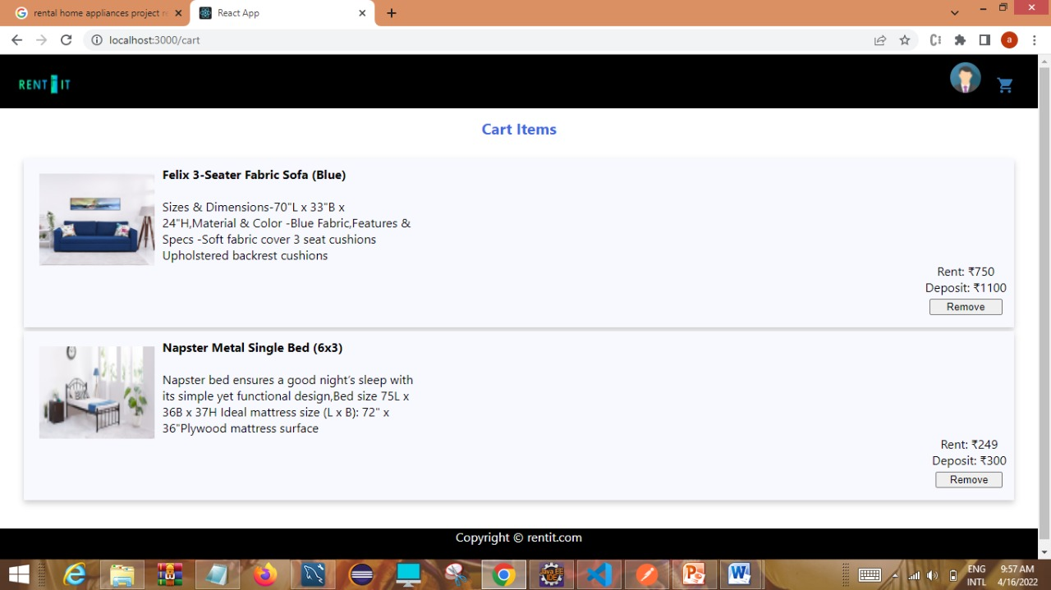

**9. CONCLUSION AND FUTURE SCOPE**

* . Rent-It can make the process of online rental home appliances streamlined.
* So this web application will helpful for migrants for getting rental appliances in effective price.